Eyewash Posting

Requirements-
Eyewashes must be readily accessible in areas with a fume hood, corrosive materials, formaldehyde, and battery changing areas, BSL-2 or BSL-3 spaces.

Eyewashes must be flushed weekly to ensure that the eyewash is working and to prevent bacteria buildup. Records must be readily available and kept for 1 yr.
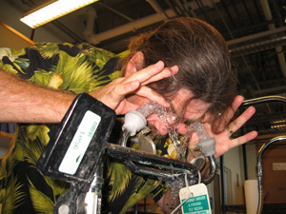
Instructions for Use
In the event of an eye exposure:

Injured person:
- Call for help, from those nearby
- Immediately, make your way to eye wash.
- Turn on eye wash and keep flushing for 15 minutes or instructed otherwise.
- Seek medical attention for every eye injury. Eyewashes are first aid only.
Image Source: UC San Diego http://blink.ucsd.edu/safety/research-lab/laboratory/eye-wash.html#Eye-wash-operation
Witness/Aid
- Help injured person get to eyewash
- Keep track of time. MINIMUM 15 minutes of flushing or until emergency responders arrive
- Call 911
- Put on gloves and help injured party keep their eyes open and head down.
- Instruct them to:
  - “Keep flushing you have ___ more minutes”
  - “Hold your eyelids open” while the water flows over the eyeballs.
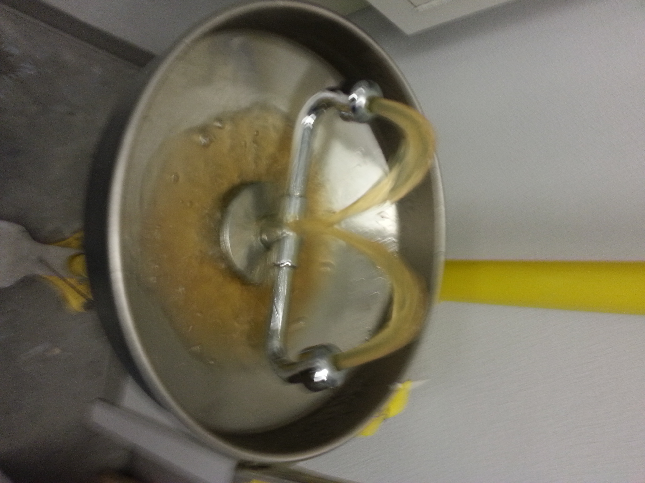
  - “Roll your eyes all around” so the water touches all of the surfaces and gets under the lids.
  - “Wash both eyes” even if you think you only contaminated one.
  - “Remove contact lenses” during the flushing.
  - “Don’t rub your eyes” or try to dislodge objects from your eye.
Weekly Check
Once a week
- Run eyewash until water is clear and colorless. (important to inhibit bacterial growth may take up to 15 min)
Check:
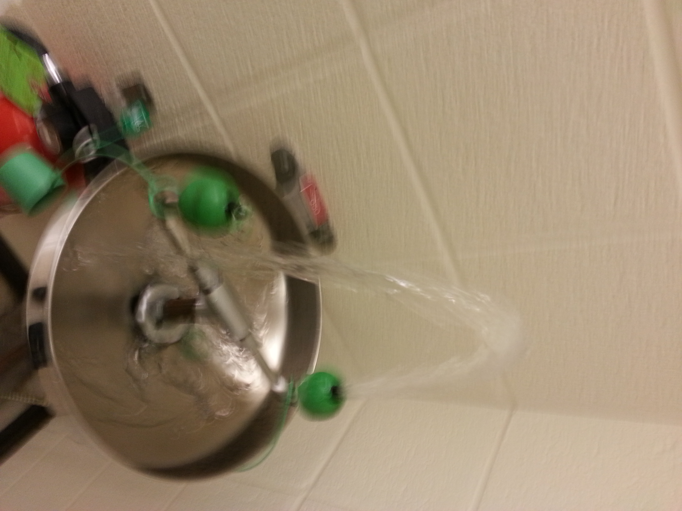
- accessibility
  - area around the eyewash station is clear of obstruction, debris or tripping hazards
- eyewash station operates correctly:
  - activating arm operates smoothly and remains open when released
  - water flows continuously, with each nozzle expelling water in roughly equal amounts and equal height
  - Report any problems to Facilities Management at 612-624-2900

Flush Record
Date | Initials |  | Date | Initials |  | Date | Initials

Post this checklist next to each eyewash station and keep as a record for 1 year.

NOTE- FM also tests showers & eyewashes annually. The record of this check is on a small green tag attached to the equipment. Please: 1) do not write on this tag. 2) Contact FM if the last record was more than one year ago.

