Alternatives to Continuous Open Flame use in
Biological Safety Cabinets

The University of Minnesota prohibits continuous open flame burners in biological safety cabinets (BSC).
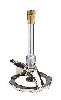
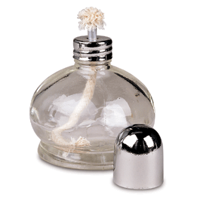

Continuous open flame burners include Bunsen burners, alcohol burners or any hands free open flame device that does not shut off automatically after a few seconds.
Continuous open flames used in a BSC can:
- Disrupt the air flow which must be maintained to prevent compromising the protection to the worker and to the work being performed
- Cause excessive heat buildup which may damage the HEPA filters adhesives and gaskets, creating a breach of containment
- Present potential for fires and explosions from gas leaks due to concentration of recirculated gas buildup
- Can inactivate the manufacturers’ warranties and void safety approval for BSC

Current University construction codes prohibit the installation of natural gas lines to biological safety cabinets. Manufacturer labels indicate that gas should not be plumbed into biological safety cabinets. This is due, in part, to the risk of gas from leaks becoming concentrated because of air recirculation in the cabinet.
The BMBL states the following: Open flames are neither required nor recommended in the near microbe-free environment of a biological safety cabinet. On an open bench, flaming the neck of a culture vessel will create an upward air current that prevents microorganisms from falling into the tube or flask. An open flame in a BSC, however, creates turbulence that disrupts the pattern of HEPA-filtered air being supplied to the work surface. When deemed absolutely necessary and approved by the appropriate facility authorities after a thorough risk assessment, touch-plate micro burners equipped with a pilot light to provide a flame on demand may be used. Internal cabinet air disturbance and heat buildup will be minimized. The burner must be turned off when work is completed. Small electric furnaces are available for decontaminating bacteriological loops and needles and are preferable to an open flame inside the BSC. Disposable loops should be used whenever possible.
Biosafety in Microbiological and Biomedical Laboratories—6th Edition

Flame on Demand Products
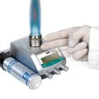

Gas cartridge automatic ignition burners turn on for set time only when needed and prevent gas leakage if inadvertently extinguished.
FIREBOY | Safety Bunsen Burner | INTEGRA

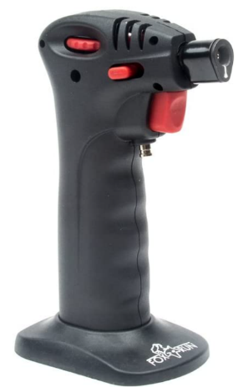

A hand held “Chef’s Torch” , without hands free operation, is a low cost alternative for quick flame needs. Temperature can reach 1000°C or higher.
Butane Creme Brulee Torch

No-Flame Alternatives
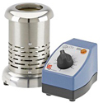
Electric Bunsen burners produce radiant heat in a temperature range from 800 to 1000°C (1472 to 1832°F).
Electric Bunsen Burner VWR

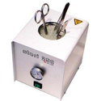
Dry bead steralizers using glass beads in the well are maintained at 250°C for complete destruction of microorganisms and spores in just seconds for metal or glass instruments.
Dry Bead Sterilizer Sigma Aldrich

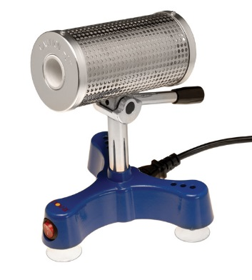
Electric micro incinerators sterilize inoculating loops or needles within seconds without open flame, this also eliminates aerosolizing of microorganisms, with attachments it can also be used to heat fix microscope slides.
Micro-Incinerator, 5° to 40°C Temp. Range (C), 815 °C Max. Temp. (C), Ceramic

Alternately, using disposable or autoclavable tools may be more cost effective.

Do not use sprayed alcohol to disinfect inside of a BSC when any of the above are in use or still hot after shutting off

